Lesson 08 - Ajax and Partial Page Update

1. If you are yet to complete project setup, please perform project setup following instructions in **C286 L08 Project Setup.docx** first.
2. Open **Task List** window from the menu **VIEW**, **Task List**. Use the **Filter** function in the Project heading to display only the Task for Lesson08.

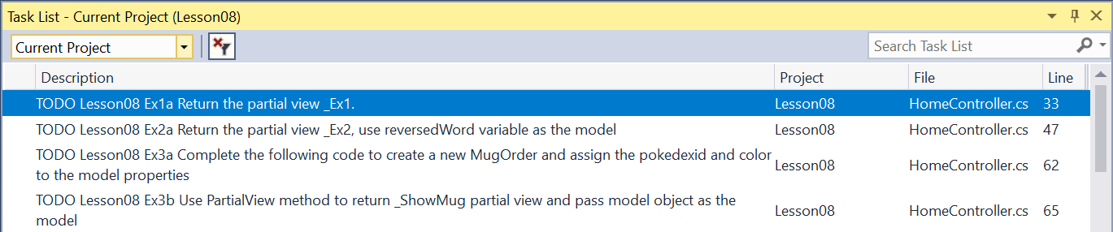

1. **Activity 1:**
   * + 1. Perform all 3 exercises: **Ex1a to b**, **Ex2a to c**, **Ex3a to d**.

You need to open **PPUExercise1.cshtml**, **PPUExercise2.cshtml** and **CreateMugOrder.cshtml** to see all tasks.

* + - 1. Refer to the Student Notes Section 1 slides to help you complete the task.
      2. Your lecturer will show verification requirement and answer on the screen. Follow the lead of your lecturer.

# Solving the Problem

1. You can complete the problem by following the **Solution Tasks** in the project. You need to open **RPNotes/Index.cshtml** and **_Shared/_Note.cshtml** to see all solution tasks.

# Testing Your Solution

1. Go through the following Test Cases and capture the screen shots in this worksheet:
   * + 1. Navigate through all modules and lessons, the note for each lesson should be updated through partial page update.

* + - 1. Try to save notes to see whether proper message is displayed.

* + - 1. Navigate to the lesson with new notes saved and ensure that the notes are indeed saved.
      2. Graphical user interface, application, Teams

         Description automatically generated
      3. Graphical user interface, text, application, email

         Description automatically generated

1. Provide other test cases here and screen shots to demonstrate that your web app is functioning well.

*— End of Worksheet —*